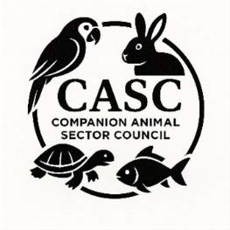
The Companion Animal Sector Council (CASC)

Membership Application Form
Please complete the details below and return your membership form to secretariat@casc.org.uk Please do NOT send any membership fee until you have received confirmation that your membership has been approved.
Organisation Details
Organisation Name
Address

Contact Name
Contact Telephone Number
Contact email
Please provide a brief description of your organisation, its aims and why you would like to become a member of CASC. This can be provided as a separate sheet if preferred.

Please mark “X” below in all sections that would apply to your organisation.
Sector |  | Organisation type |  | CASC Sub-Groups of interest (if known)
Trade |  | Hobbyist/Keeper group |  | Mammals
Keeper/Hobbyist |  | Ltd. Company |  | Birds
Zoo/Public collection |  | Private Company |  | Reptiles and Amphibians
Education |  | Private Individual |  | Fish
Research |  | Membership organisation |  | Selling of Animals
Animal Welfare |  | Lobbing Organisation |  | Internet
Animal Rights |  | Charity |  | Education
Other |  | Other |  | LAIA Working Group
 |  |  |  | Regulation of Rescue and Rehoming Operations WG
 |  |  |  | Temporary sales events and exhibitions WG

Membership Fees
Minimum of £2000 | Large organisations.  Large charities/welfare organisations, Trade Associations, Businesses, Hobby Groups with income of over £1m
£1,000 | Smaller organisations.  Charities/welfare organisations, Trade Associations, Businesses, Hobby Groups with income of between £50,000 and £1m
£200 | Hobbyist groups, small independent charities, rescues organisations, other organisations that have an income.
£100 | Very small "micro" hobby groups, small organisations in the first year of their existence, organisations that have no income or show severely restricted funding where payment of a higher fee may severely affect them.
£0 | Invited individuals or organisations that would not normally be members

Before returning your membership application, please read the CASC Terms of Reference to ensure that you understand the aims of the group, how the group is organised and run and the member code of conduct. The Terms of Reference can be found here https://casc.org.uk/documents

SC |  | C |  | Mem. Cat.
For office use only

